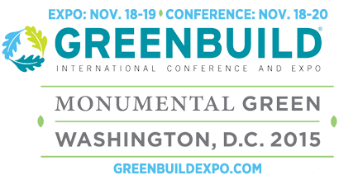
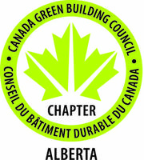


Alberta Associate Exhibitor Program- Mission to Greenbuild 2015
Washington D.C.
November 17-19, 2015
Please fill out the following form in order for your company to be included in the Alberta 2015 Greenbuild Company Directory that will be used at the Greenbuild 2015 Conference and Expo. This directory will be distributed at the Alberta pavilion, and will also be circulated electronically to interested parties.
Company profiles will also be used at a subsequent mission to the 2016 International Builders Show.
Please return this completed form to Sean Mallany, Senior Intergovernmental Officer, at: sean.mallany@gov.ab.ca.
All submissions must be received by September 22, 2015 in order to be included in the directory.
Profile for Alberta 2015 Greenbuild Company Directory:
Company Name
Contact Individual
Title
Alberta-based Street Address
City
Province | Alberta
Postal Code
Phone
Email Address:
Website:
U.S. States That Your Company Is Currently Doing Business In:
Company Keywords:
Keywords will be used in an index of company technologies and capabilities.
For company logo submissions, please provide a separate image file for us to use.

We recommend that images be submitted in an .ai or .eps file format, with a minimum resolution of 300 dots per inch. If an .ai or .eps file format is not available, a .png file with a transparent background may be used as well.
Company Profile (maximum 1000 characters) We recommend that you use this text to describe your company’s unique value proposition, company capabilities, and technologies:

Application form for Alberta Chapter of the Canada Green Building Council Complementary Membership
Please note that memberships must be for individuals that are not currently Chapter members.
Company Name:
Contact Individual
Title
Alberta-based Street Address
City
Province | Alberta
Postal Code
Phone
Email Address:
Website:

Contact Individual
Title
Alberta-based Street Address
City
Province | Alberta
Postal Code
Phone
Email Address:
Website:

